**1] Exercise**

<?xml version="1.0" encoding="utf-8"?>

<AbsoluteLayout xmlns:android="http://schemas.android.com/apk/res/android"

xmlns:app="http://schemas.android.com/apk/res-auto"

xmlns:tools="http://schemas.android.com/tools"

android:layout_width="match_parent"

android:layout_height="match_parent"

tools:context=".MainActivity">

<TextView

android:layout_width="wrap_content"

android:layout_height="wrap_content"

android:layout_x="121dp"

android:layout_y="36dp"

android:text="Single Radio Buttons" />

<RadioButton

android:id="@+id/rbtn1"

android:layout_width="wrap_content"

android:layout_height="wrap_content"

android:layout_x="15dp"

android:layout_y="96dp"

android:text="Radio Button 1" />

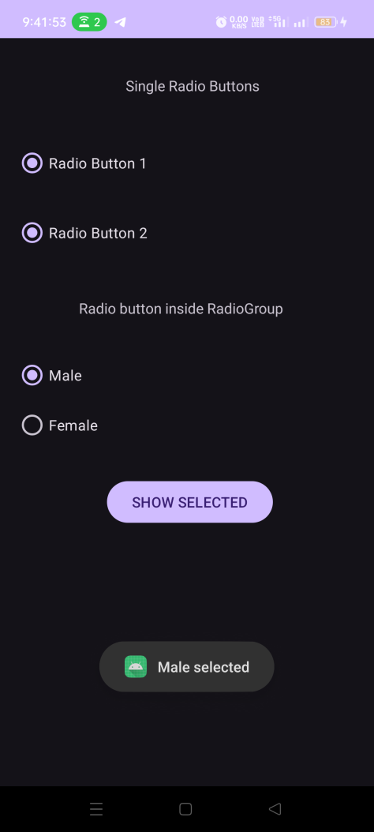

<RadioButton

android:id="@+id/rbtn2"

android:layout_width="wrap_content"

android:layout_height="wrap_content"

android:layout_x="15dp"

android:layout_y="163dp"

android:text="Radio Button 2" />

<TextView

android:layout_width="wrap_content"

android:layout_height="wrap_content"

android:layout_x="76dp"

android:layout_y="250dp"

android:text="Radio button inside RadioGroup" />

<RadioGroup

android:id="@+id/radio_group"

android:layout_width="wrap_content"

android:layout_height="wrap_content"

android:orientation="vertical"

android:layout_x="15dp"

android:layout_y="300dp">

<RadioButton

android:id="@+id/rbtn3"

android:layout_width="match_parent"

android:layout_height="wrap_content"

android:layout_x="30dp"

android:layout_y="340dp"

android:text="Male" />

<RadioButton

android:id="@+id/rbtn4"

android:layout_width="match_parent"

android:layout_height="wrap_content"

android:layout_x="30dp"

android:layout_y="340dp"

android:text="Female" />

</RadioGroup>

<Button

android:id="@+id/btn"

android:layout_width="wrap_content"

android:layout_height="wrap_content"

android:layout_x="103dp"

android:layout_y="422dp"

android:text="SHOW SELECTED" />

</AbsoluteLayout>